Restricted Loci

Definition
# Source: AI Source: Provided by: [Data Path: Persons Table -> ID Column: 1, Name_En Column: Motasem Essam] -> From: [ChatGPT] on [7/25/2026]
Restricted Loci are loci in which the set of points satisfying a geometric condition is limited by one or more additional restrictions.
A restriction can limit:
- the location of the point,
- the direction,
- the portion of a curve,
- the geometric object on which the point lies,
- an interval or boundary,
- or another geometric condition.
Thus, instead of taking the entire locus, we take only the part that satisfies the additional restriction.
$$\boxed{\text{Restricted Locus}=\text{Basic Locus}∩\text{Restriction}}$$

Simple Definition
# Source: AI Source: Provided by: [Data Path: Persons Table -> ID Column: 1, Name_En Column: Motasem Essam] -> From: [ChatGPT] on [7/25/2026]
A restricted locus is the part of a locus that remains after additional conditions limit where the point may lie.
For example, the locus of points $5$cm from $O$is a complete circle:
$$OP=5.$$
If the point must also lie above a horizontal line through $O$, only the upper semicircle remains.

Fundamental Concept
# Source: AI Source: Provided by: [Data Path: Persons Table -> ID Column: 1, Name_En Column: Motasem Essam] -> From: [ChatGPT] on [7/25/2026]
A normal locus is obtained from one geometric condition:
$$\text{Condition}→\text{Locus}.$$
A restricted locus adds another condition:
$$\boxed{\text{Locus Condition}+\text{Restriction}→\text{Restricted Locus}}$$
For example:
$$PA=5$$
gives a circle.
Adding:
$$P\text{ lies above }AB$$
restricts the circle to one side.
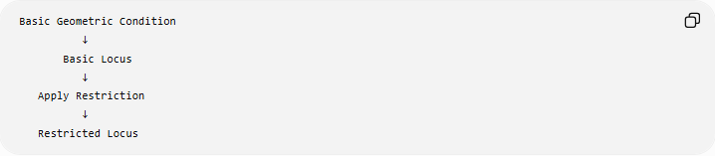
Basic Geometric Condition
↓
Basic Locus
↓
Apply Restriction
↓
Restricted Locus

Main Types of Restricted Loci
# Source: AI Source: Provided by: [Data Path: Persons Table -> ID Column: 1, Name_En Column: Motasem Essam] -> From: [ChatGPT] on [7/25/2026]
A practical classification is:
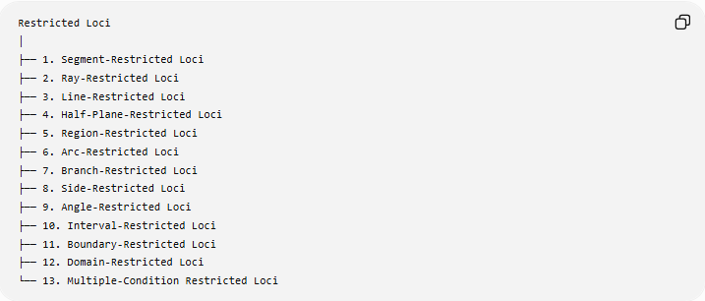
Restricted Loci
│
├── 1. Segment-Restricted Loci
├── 2. Ray-Restricted Loci
├── 3. Line-Restricted Loci
├── 4. Half-Plane-Restricted Loci
├── 5. Region-Restricted Loci
├── 6. Arc-Restricted Loci
├── 7. Branch-Restricted Loci
├── 8. Side-Restricted Loci
├── 9. Angle-Restricted Loci
├── 10. Interval-Restricted Loci
├── 11. Boundary-Restricted Loci
├── 12. Domain-Restricted Loci
└── 13. Multiple-Condition Restricted Loci
These are descriptive/practical categories rather than a universally standardized formal classification.

1. Segment-Restricted Loci
# Source: AI Source: Provided by: [Data Path: Persons Table -> ID Column: 1, Name_En Column: Motasem Essam] -> From: [ChatGPT] on [7/25/2026]
Definition
A segment-restricted locus is a locus limited to a particular line segment.
If the unrestricted locus is:
$$P∈l,$$
but $P$is required to lie between two fixed points $A$and $B$, then:
$$\boxed{P∈\overset{‾}{AB}}.$$
Example
Suppose:
$$P∈l$$
and $P$must lie between $A$and $B$.
The unrestricted locus is the entire line:
$$l.$$
The restricted locus is only:
$$\boxed{\overset{‾}{AB}}.$$
Important
$$\boxed{\text{Line}→\text{Segment restriction}}$$
removes all points outside the segment.

2. Ray-Restricted Loci
# Source: AI Source: Provided by: [Data Path: Persons Table -> ID Column: 1, Name_En Column: Motasem Essam] -> From: [ChatGPT] on [7/25/2026]
Definition
A ray-restricted locus is limited to one direction from a fixed point.
For example:
$$P∈\vec{AB}.$$
The unrestricted object may be the entire line $AB$, but the restriction keeps only the ray beginning at $A$and passing through $B$.
Example
Suppose the basic locus is:
$$P∈\overset{↔}{AB}.$$
If the restriction is:
$$P\text{ lies on the ray from }A\text{ through }B,$$
then:
$$\boxed{P∈\vec{AB}}.$$
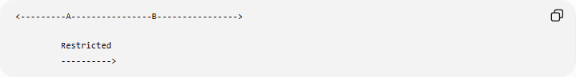
<---------A----------------B---------------->

Restricted
---------->

3. Line-Restricted Loci
# Source: AI Source: Provided by: [Data Path: Persons Table -> ID Column: 1, Name_En Column: Motasem Essam] -> From: [ChatGPT] on [7/25/2026]
A locus can also be restricted to a particular line.
Example
Suppose:
$$PA=5$$
gives a circle centered at $A$.
If we additionally require:
$$P∈l,$$
then the restricted locus is:
$$\boxed{\left\{P:PA=5\right\}∩l}$$
which consists of the intersection points between the circle and the line.
Depending on the position of the line, there may be:
$$\boxed{0, 1,\text{ or }2}$$
points.

4. Half-Plane-Restricted Loci
# Source: AI Source: Provided by: [Data Path: Persons Table -> ID Column: 1, Name_En Column: Motasem Essam] -> From: [ChatGPT] on [7/25/2026]
Definition
A half-plane restriction limits the locus to one side of a line.
Suppose:
$$l:y=0.$$
The two half-planes are:
$$y>0$$
and:
$$y<0.$$
Example
The locus:
$$x^{2}+y^{2}=25$$
is a complete circle.
If:
$$y>0,$$
then the restricted locus is the upper semicircle.
If:
$$y<0,$$
then the restricted locus is the lower semicircle.
Thus:
$$\boxed{x^{2}+y^{2}=25, y>0}$$
describes the upper portion.

5. Region-Restricted Loci
# Source: AI Source: Provided by: [Data Path: Persons Table -> ID Column: 1, Name_En Column: Motasem Essam] -> From: [ChatGPT] on [7/25/2026]
A locus can be restricted to a particular geometric region.
For example:
$P$is exactly $5$units from $A$, and $P$must lie inside triangle $ABC$.
The basic locus is:
$$PA=5$$
which is a circle.
The restriction is:
$$P∈△ABC.$$
Therefore:
$$\boxed{L=C\left(A , 5\right)∩△ABC}$$
Only the portion of the circle inside the triangle belongs to the restricted locus.

6. Arc-Restricted Loci
# Source: AI Source: Provided by: [Data Path: Persons Table -> ID Column: 1, Name_En Column: Motasem Essam] -> From: [ChatGPT] on [7/25/2026]
Definition
An arc-restricted locus is a circular locus limited to a particular arc.
This occurs frequently with fixed-angle loci.
Suppose:
$$∠APB=θ.$$
The unrestricted geometric construction can produce circular arcs through $A$and $B$.
But if $P$must lie on a particular side of $AB$, only the corresponding arc is selected.
Example
For:
$$∠APB={90}^{∘},$$
Thales' theorem gives a circle with $AB$as diameter.
If $P$must be above $AB$, the restricted locus is only the upper semicircle.
$$\boxed{\text{Restricted locus}=\text{upper semicircle}}$$

7. Branch-Restricted Loci
# Source: AI Source: Provided by: [Data Path: Persons Table -> ID Column: 1, Name_En Column: Motasem Essam] -> From: [ChatGPT] on [7/25/2026]
Some loci contain multiple branches.
The most important example is a hyperbola.
A hyperbola has two branches:
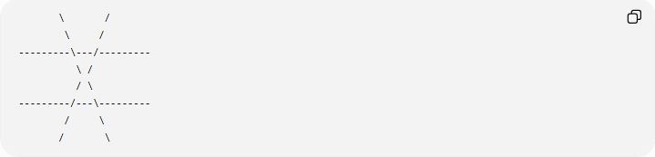
\ /
\ /
---------\---/---------
\ /
/ \
---------/---\---------
/ \
/ \
If a problem requires $P$to lie on only one branch, then the locus is branch-restricted.
Example
For:
$$\frac{x^{2}}{9}-\frac{y^{2}}{4}=1,$$
the hyperbola has:
- a right branch,
- a left branch.
If:
$$x>0,$$
only the right branch remains.
Thus:
$$\boxed{\frac{x^{2}}{9}-\frac{y^{2}}{4}=1, x>0}$$
describes the right branch.

8. Side-Restricted Loci
# Source: AI Source: Provided by: [Data Path: Persons Table -> ID Column: 1, Name_En Column: Motasem Essam] -> From: [ChatGPT] on [7/25/2026]
A locus may be restricted to one side of a particular geometric object.
Example
Suppose:
$$PA=PB.$$
The unrestricted locus is the perpendicular bisector of $AB$.
If the problem additionally requires $P$to lie inside a particular angle or triangle, only the portion of the perpendicular bisector satisfying that condition is retained.
For example:
$$\boxed{PA=PB, P∈△ABC}$$
gives the portion of the perpendicular bisector that lies inside the triangle.

9. Angle-Restricted Loci
# Source: AI Source: Provided by: [Data Path: Persons Table -> ID Column: 1, Name_En Column: Motasem Essam] -> From: [ChatGPT] on [7/25/2026]
A locus can be restricted to a particular angular region.
Example
Suppose:
$$PA=PB.$$
The complete locus is the perpendicular bisector of $AB$.
If $P$must additionally lie inside a specified angle, then:
$$\boxed{L=\left\{\text{perpendicular bisector of }AB\right\}∩\left\{\text{specified angle}\right\}}$$
Only the part inside the angle is retained.

10. Interval-Restricted Loci
# Source: AI Source: Provided by: [Data Path: Persons Table -> ID Column: 1, Name_En Column: Motasem Essam] -> From: [ChatGPT] on [7/25/2026]
In coordinate geometry, a locus may be restricted by an interval.
Example
Consider the line:
$$y=2x+1.$$
The unrestricted locus contains every point:
$$\left(x , 2x+1\right), x∈R.$$
Suppose:
$$0≤x≤3.$$
Then only:
$$\boxed{\left(x , 2x+1\right), 0≤x≤3}$$
belongs to the restricted locus.
The endpoints are:
$$\left(0 , 1\right)$$
and:
$$\left(3 , 7\right).$$
So the restricted locus is the segment joining these points.

11. Boundary-Restricted Loci
# Source: AI Source: Provided by: [Data Path: Persons Table -> ID Column: 1, Name_En Column: Motasem Essam] -> From: [ChatGPT] on [7/25/2026]
Sometimes the restriction selects only a boundary.
Example
Consider the disk:
$$x^{2}+y^{2}≤25.$$
This represents all points inside or on the circle.
If the restriction requires:
$$x^{2}+y^{2}=25,$$
only the boundary remains:
$$\boxed{\text{circle}}$$
rather than the entire disk.
This distinction is important:
$$\boxed{<\text{ or }≤→\text{region}}$$
while:
$$\boxed{=→\text{boundary locus}}$$
in this example.

12. Domain-Restricted Loci
# Source: AI Source: Provided by: [Data Path: Persons Table -> ID Column: 1, Name_En Column: Motasem Essam] -> From: [ChatGPT] on [7/25/2026]
In coordinate equations, the equation may describe a larger curve, while a domain restriction selects only part of it.
Example
Consider:
$$y=x^{2}.$$
The unrestricted parabola has:
$$-∞<x<∞.$$
If:
$$0≤x≤4,$$
the restricted locus is only the portion of the parabola between:
$$\left(0 , 0\right)$$
and:
$$\left(4 , 16\right).$$
Thus:
$$\boxed{y=x^{2}, 0≤x≤4}$$
is a restricted parabola.

13. Multiple-Condition Restricted Loci
# Source: AI Source: Provided by: [Data Path: Persons Table -> ID Column: 1, Name_En Column: Motasem Essam] -> From: [ChatGPT] on [7/25/2026]
A locus can have several restrictions simultaneously.
For example:
$$PA=5$$
with:
$$P∈△ABC$$
and:
$$x>0.$$
Then:
$$\boxed{L=\left\{P:PA=5\right\}∩△ABC∩\left\{\left(x , y\right):x>0\right\}}$$
Every restriction must be satisfied.
This is essentially an intersection of sets.

Restricted Locus as an Intersection
# Source: AI Source: Provided by: [Data Path: Persons Table -> ID Column: 1, Name_En Column: Motasem Essam] -> From: [ChatGPT] on [7/25/2026]
The most important mathematical principle is:
$$\boxed{\text{Restricted Locus}=\text{Basic Locus}∩\text{Restriction Set}}$$
For example:
Circle restricted to a half-plane
$$L=\left\{\left(x , y\right):x^{2}+y^{2}=25\right\}$$
and:
$$R=\left\{\left(x , y\right):y≥0\right\}.$$
Therefore:
$$\boxed{L_{\text{restricted}}=L∩R}.$$
The result is the upper semicircle, including endpoints.

Example: Circle Restricted to a Triangle
# Source: AI Source: Provided by: [Data Path: Persons Table -> ID Column: 1, Name_En Column: Motasem Essam] -> From: [ChatGPT] on [7/25/2026]
Let:
$$A=\left(0 , 0\right)$$
and suppose:
$$PA=4.$$
The unrestricted locus is:
$$\boxed{x^{2}+y^{2}=16}.$$
Now require:
$$P∈△ABC.$$
Then:
$$\boxed{L=\left\{\left(x , y\right):x^{2}+y^{2}=16\right\}∩△ABC}$$
Only the portion of the circle lying inside the triangle is the answer.

Example: Fixed Distance from a Line with a One-Sided Restriction
# Source: AI Source: Provided by: [Data Path: Persons Table -> ID Column: 1, Name_En Column: Motasem Essam] -> From: [ChatGPT] on [7/25/2026]
Suppose:
$$d\left(P , l\right)=3.$$
The unrestricted locus consists of two parallel lines:
$$l_{1}, l_{2}.$$
If the problem says:
$P$must lie on one specified side of $l$,
only one of those parallel lines is retained.
For example, if:
$$l:y=0,$$
then:
$$d\left(P , l\right)=3$$
gives:
$$y=3$$
or:
$$y=-3.$$
If $P$must lie above $l$:
$$\boxed{y=3}.$$
Thus the restriction eliminates $y=-3$.

Example: Restricted Perpendicular Bisector
# Source: AI Source: Provided by: [Data Path: Persons Table -> ID Column: 1, Name_En Column: Motasem Essam] -> From: [ChatGPT] on [7/25/2026]
Let:
$$A=\left(0 , 0\right), B=\left(8 , 0\right).$$
The locus:
$$PA=PB$$
is:
$$\boxed{x=4}.$$
Suppose $P$must also lie inside the upper half-plane:
$$y>0.$$
Then the restricted locus is:
$$\boxed{x=4, y>0}.$$
It is only the upper ray of the perpendicular bisector.

Example: Restricted Hyperbola
# Source: AI Source: Provided by: [Data Path: Persons Table -> ID Column: 1, Name_En Column: Motasem Essam] -> From: [ChatGPT] on [7/25/2026]
Consider:
$$\frac{x^{2}}{25}-\frac{y^{2}}{9}=1.$$
The complete locus has two branches.
If:
$$x≥5,$$
only the right-hand portion beginning at the vertex $\left(5 , 0\right)$is retained.
Thus:
$$\boxed{\frac{x^{2}}{25}-\frac{y^{2}}{9}=1, x≥5}$$
is a restricted portion of the right branch.

Restricted Loci and Inequalities
# Source: AI Source: Provided by: [Data Path: Persons Table -> ID Column: 1, Name_En Column: Motasem Essam] -> From: [ChatGPT] on [7/25/2026]
Restrictions are frequently expressed using inequalities.
For example:
Full circle
$$x^{2}+y^{2}=25$$
Inside circle
$$x^{2}+y^{2}<25$$
Upper semicircle
$$x^{2}+y^{2}=25, y≥0$$
Right semicircle
$$x^{2}+y^{2}=25, x≥0.$$
Thus, inequalities can be used to select portions of a locus.

Open vs Closed Restrictions
# Source: AI Source: Provided by: [Data Path: Persons Table -> ID Column: 1, Name_En Column: Motasem Essam] -> From: [ChatGPT] on [7/25/2026]
A restriction can include or exclude its boundary.
Compare:
$$y>0$$
with:
$$y≥0.$$
$$y>0$$
The $x$-axis is excluded.
$$y≥0$$
The $x$-axis is included.
For a circle:
$$x^{2}+y^{2}=25, y>0$$
gives the upper semicircle without its endpoints.
Whereas:
$$x^{2}+y^{2}=25, y≥0$$
gives the upper semicircle including its endpoints.

Restricted Loci and Intersection of Loci
# Source: AI Source: Provided by: [Data Path: Persons Table -> ID Column: 1, Name_En Column: Motasem Essam] -> From: [ChatGPT] on [7/25/2026]
There is a close relationship:
$$\boxed{\text{Restriction}→\text{Additional Condition}→\text{Intersection}}$$
For example:
$$PA=5$$
gives:
$$L_{1}=\text{circle}.$$
And:
$$P∈△ABC$$
gives:
$$L_{2}=△ABC.$$
Then:
$$\boxed{L_{\text{restricted}}=L_{1}∩L_{2}}$$
So restricted loci are often obtained through intersection.

Restricted Loci vs Union of Loci
# Source: AI Source: Provided by: [Data Path: Persons Table -> ID Column: 1, Name_En Column: Motasem Essam] -> From: [ChatGPT] on [7/25/2026]
These concepts are related but opposite in their logical behavior.
Restricted Locus
Uses an additional AND condition:
$$\boxed{L_{\text{restricted}}=L_{1}∩R}$$
Union of Loci
Uses an OR condition:
$$\boxed{L=L_{1}∪L_{2}}$$
Therefore:
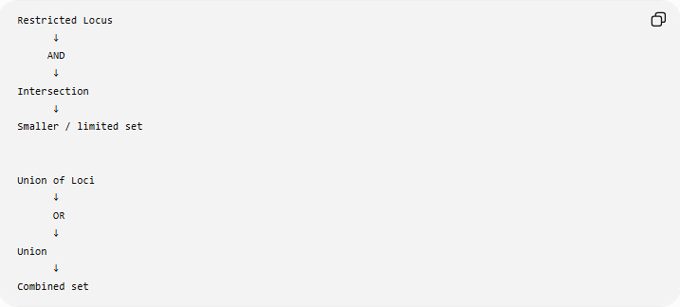
Restricted Locus
↓
AND
↓
Intersection
↓
Smaller / limited set

Union of Loci
↓
OR
↓
Union
↓
Combined set

Restricted Loci vs Unrestricted Loci
# Source: AI Source: Provided by: [Data Path: Persons Table -> ID Column: 1, Name_En Column: Motasem Essam] -> From: [ChatGPT] on [7/25/2026]
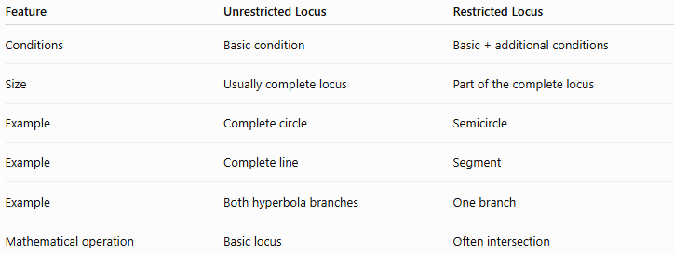
Feature | Unrestricted Locus | Restricted Locus
Conditions | Basic condition | Basic + additional conditions
Size | Usually complete locus | Part of the complete locus
Example | Complete circle | Semicircle
Example | Complete line | Segment
Example | Both hyperbola branches | One branch
Mathematical operation | Basic locus | Often intersection

Important Geometric Examples
# Source: AI Source: Provided by: [Data Path: Persons Table -> ID Column: 1, Name_En Column: Motasem Essam] -> From: [ChatGPT] on [7/25/2026]
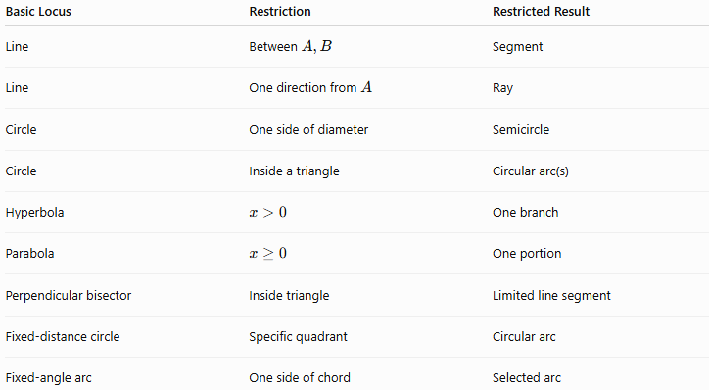
Basic Locus | Restriction | Restricted Result
Line | Between $A,B$ | Segment
Line | One direction from $A$ | Ray
Circle | One side of diameter | Semicircle
Circle | Inside a triangle | Circular arc(s)
Hyperbola | $$x>0$$ | One branch
Parabola | $$x≥0$$ | One portion
Perpendicular bisector | Inside triangle | Limited line segment
Fixed-distance circle | Specific quadrant | Circular arc
Fixed-angle arc | One side of chord | Selected arc

Classification Summary
# Source: AI Source: Provided by: [Data Path: Persons Table -> ID Column: 1, Name_En Column: Motasem Essam] -> From: [ChatGPT] on [7/25/2026]
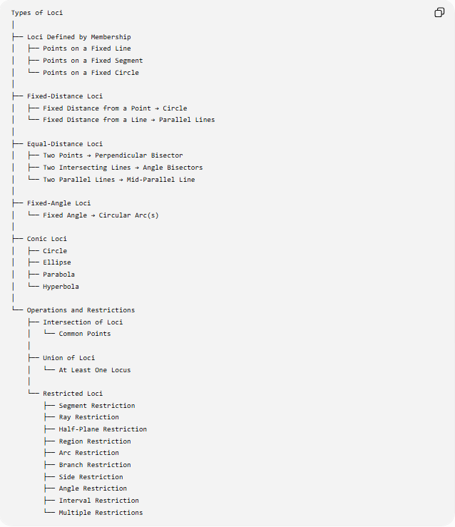
Types of Loci
│
├── Loci Defined by Membership
│ ├── Points on a Fixed Line
│ ├── Points on a Fixed Segment
│ └── Points on a Fixed Circle
│
├── Fixed-Distance Loci
│ ├── Fixed Distance from a Point → Circle
│ └── Fixed Distance from a Line → Parallel Lines
│
├── Equal-Distance Loci
│ ├── Two Points → Perpendicular Bisector
│ ├── Two Intersecting Lines → Angle Bisectors
│ └── Two Parallel Lines → Mid-Parallel Line
│
├── Fixed-Angle Loci
│ └── Fixed Angle → Circular Arc(s)
│
├── Conic Loci
│ ├── Circle
│ ├── Ellipse
│ ├── Parabola
│ └── Hyperbola
│
└── Operations and Restrictions
├── Intersection of Loci
│ └── Common Points
│
├── Union of Loci
│ └── At Least One Locus
│
└── Restricted Loci
├── Segment Restriction
├── Ray Restriction
├── Half-Plane Restriction
├── Region Restriction
├── Arc Restriction
├── Branch Restriction
├── Side Restriction
├── Angle Restriction
├── Interval Restriction
└── Multiple Restrictions

Key Formula
# Source: AI Source: Provided by: [Data Path: Persons Table -> ID Column: 1, Name_En Column: Motasem Essam] -> From: [ChatGPT] on [7/25/2026]
The central idea can be written as:
$$\boxed{L_{\text{restricted}}=L∩R}$$
where:
- $L$= original/basic locus
- $R$= set defined by the restriction
- $L_{\text{restricted}}$= portion satisfying both.
For multiple restrictions:
$$\boxed{L_{\text{restricted}}=L∩R_{1}∩R_{2}∩⋯∩R_{n}}$$
Therefore a point $P$belongs to the restricted locus exactly when:
$$\boxed{P∈L \text{and} P∈R_{1} \text{and} P∈R_{2} ⋯}$$

Key Points
# Source: AI Source: Provided by: [Data Path: Persons Table -> ID Column: 1, Name_En Column: Motasem Essam] -> From: [ChatGPT] on [7/25/2026]
- A restricted locus is a limited portion of a basic locus.
- Restrictions add additional conditions to the original locus.
- The fundamental relationship is:
$$\boxed{\text{Restricted Locus}=\text{Locus}∩\text{Restriction}}$$
- Common restrictions include:
  - segment,
  - ray,
  - half-plane,
  - region,
  - arc,
  - branch,
  - side,
  - angle,
  - interval.
- A complete circle can become a semicircle or arc.
- A complete line can become a segment or ray.
- A two-branch hyperbola can be restricted to one branch.
- Restrictions can be expressed using equations and inequalities.
- Multiple restrictions can be applied simultaneously:
$$\boxed{L∩R_{1}∩R_{2}∩⋯∩R_{n}}$$
- Union uses OR, while restriction through intersection uses AND:
$$\boxed{\text{Union}→\text{OR}} \\ \boxed{\text{Restriction}→\text{AND}}$$

Conclusion
# Source: AI Source: Provided by: [Data Path: Persons Table -> ID Column: 1, Name_En Column: Motasem Essam] -> From: [ChatGPT] on [7/25/2026]
Restricted Loci describe situations where a geometric locus is not allowed to extend over its entire natural set. An additional geometric, positional, directional, or coordinate condition selects only the portion that satisfies the restriction.
The central principle is:
$$\boxed{\text{Basic Locus}∩\text{Restriction}=\text{Restricted Locus}}$$
For example:
$$\boxed{PA=5 \text{and} P\text{ lies above }AB}$$
changes the complete circle $PA=5$into the appropriate semicircle or arc. Thus, restricted loci are fundamentally loci obtained by applying additional constraints to an existing locus.

